Assignment 9:

Write a C program that includes a user-defined function named setBit with the signature int setBit(int num, int position);. The function should set the bit at the specified position (0-indexed) to 1 and return the modified number.

Source Code:

#include<stdio.h>
int setBit(int num, int position) {
return num | (1 << position);
}
int main() {
int num, pos, update;
printf("Enter the num : ");
scanf("%d",&num);
printf("Enter the position : ");
scanf("%d",&pos);
update = setBit(num,pos);
printf("The original number = %d",num);
printf("\nThe modified number = %d",update);
return 0;
}

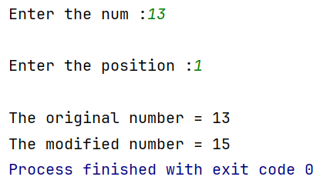
Output:

